MC Scenario Integration with LCMS

Integration Specification

Contents

Overview 2

Interface Builder 2

Preview Mode 4

# Overview

In this template, the author select MC template to set the data with the help of interface builder. Template gets data and display dynamically in the preview mode.

Interface Builder

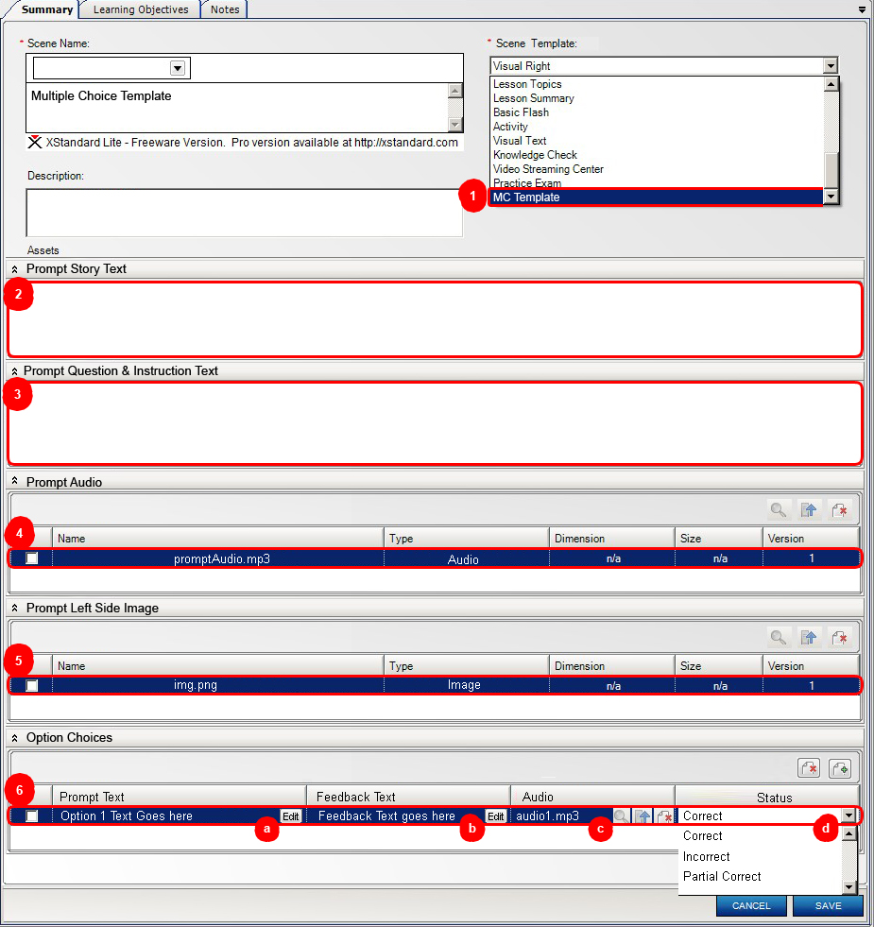

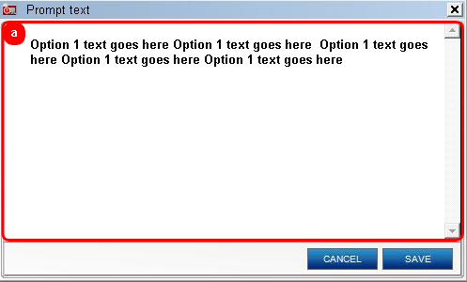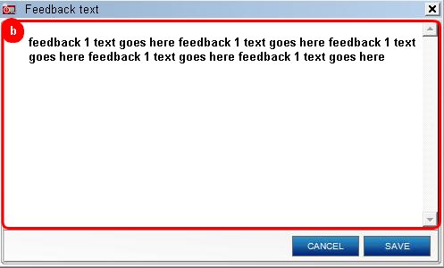

1. **Multiple Choice Scenario** scene template.
2. **Prompt story text** panel. Input text area with text formatting functionality.
3. **Prompt question & instruction text** panel. Input text area with text formatting functionality.
4. **Prompt audio** panel. Only one audio asset can attach.
5. **Prompt left side image** panel. Only one image asset can attach.
6. **Option choices** panel. Multiple items can add/delete. Each item has 4 elements.
   1. **Prompt text** element. It has edit button and it opens new popup window with input text area with text formatting functionality.
   2. **Feedback text** element. It has edit button and it opens new popup window with input text area with text formatting functionality.
   3. **Audio** element. It has 3 buttons search, upload new audio and delete. Only one audio asset can attach with each item.
   4. **Status** element. It is drop down and has three values. **Correct**, **Incorrect** and **Partial Correct**.

Preview Mode

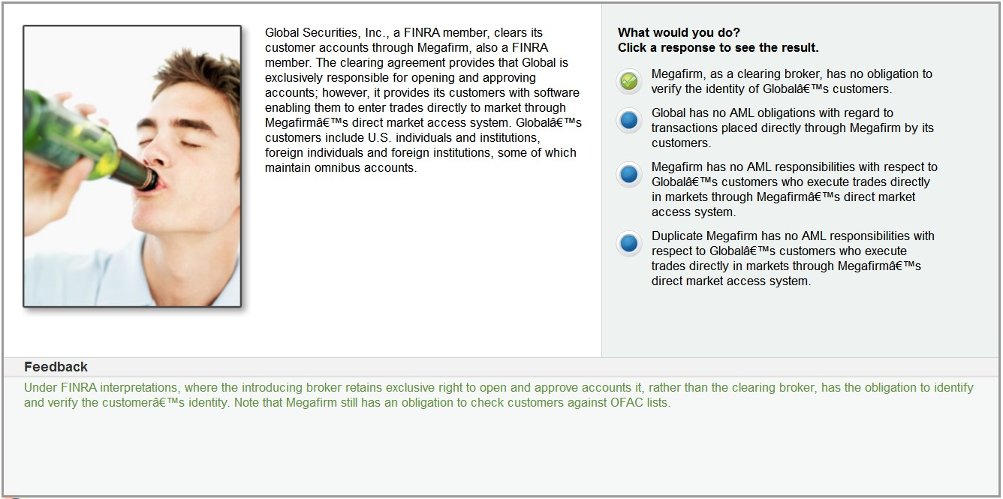

Functionality of this template is described in the **MC Scenario.docx** document.